EXPERIMENT 6: GROCERY BILL CALCULATION
Aim: To calculate the total cost of a customer's purchase after applying discounts and taxes.
Algorithm:
- Define item prices, quantities, discount, and tax rates.
- Calculate the total price.
- Subtract the discount.
- Add tax to the discounted amount.
- Display the final cost.
Code:
prices = [100, 200, 150]
qty = [2, 1, 3]
total = sum(prices[i] * qty[i] for i in range(3))
discount = total * 10 / 100
subtotal = total - discount
tax = subtotal * 5 / 100
print("Total Price:", total)
print("Discount:", discount)
print("Tax:", tax)
print("Final Cost:", subtotal + tax)
Input:
Prices = [100, 200, 150]
Quantities = [2, 1, 3]
Discount = 10%
Tax = 5%
Output: 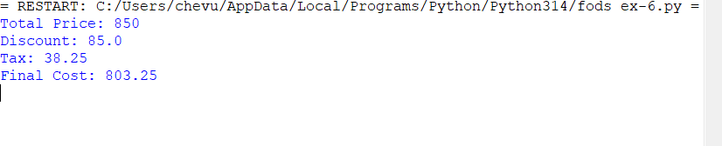
Result: Thus, the final cost of the customer's purchase after applying a 10% discount and 5% tax is ₹803.25.

